***A project Report***

**Submitted by:**

***Names Enrollment no.***

1. ***Deepak kumar (group leader) 15301060012***
2. ***Richa singh 15301060029***
3. ***Laxmi kumari 15301060017***
4. ***Mahrush perween 15301065001***
5. ***Mamta marandi 15301060018***
6. ***Md. Miraj 15301060021***
7. ***Rajeev paul 15301060025***

***Government Polytechnic Dhanbad***

***State Board of Technical Education***

***Dhanbad-828130***

***June-2018***

**Government Polytechnic Dhanbad**

***BONAFIDE CERTIFICATE***

***Certified that this project report “ ” is the bonafide work of “DEEPAK KUMAR(Reg no.- 15301060012), RICHA SINGH(Reg no.-15301060029),LAXMI KUMARI(Reg no.-15301060017), MAHRUSH PERWEEN(Reg no.-15301065001), MAMTA MARANDI(Reg no.-15301060018), MD. MIRAJ(Reg no.-15301060021), RAJEEV PAUL(Reg no.-15301060025)” who carried out the project work under my supervision.***

***SIGNATURE SIGNATURE***

***GUIDE PRINCIPAL***

***Ms.Ishrat Parveen Mr. Binod kumar sinha***

***ACKNOWLEDGEMENT***

*We take this opportunity to express our gratitude to our* ***PRINCIPAL-BINOD KUMAR SINHA*** *for providing all the facilities to complete our project work successfully.*

*We are grateful to* ***Mrs. ISHARAT PERVEEN*** *for her encouragement and inspiration that helped us through space the progress of our project work.*

*We thank all the teaching and non-teaching staff members of our department for extending their kind co-operation throughout the project work. We wish to thank all our family members and friends for their encouragement.*

***1.DEEPAK KUMAR (15301060012)***

***2.RICHA SINGH (15301060029)***

***3.LAXMI KUMARI (15301060017)***

***4.MAHRUSH PERWEEN (15301065001)***

***5.MAMTA MARANDI (15301060018)***

***6.MD. MIRAJ (15301060021)***

***7.RAJEEV PAUL (15301060025)***

***TABLE OF CONTENT***

**1. Overview of project**

**2. Requirement specification**

**2.1. Hardware requirement**

**2.2. Software requirement**

**3. Project details**

**4. Designing**

**4.1. Coding**

**5. Screenshots**

**6. Testing**

**6.1. System testing**

**6.2. Testing methodology**

**6.2.1. White Box Testing**

**6.2.2. Black Box Testing**

**6.2.3. Unit testing**

**7. Conclusion**

***1. OVERVIEW OF PROJECT***

*In our project , we are representing a journey scenario which includes the car’s journey , traffic signal, accidental case, policeman, fast driving situation, etc.*

***2. REQUIREMENT SPECIFICATION***

***2.1. Hardware requirement***

Processor type : Intel i3 (6th generation)

Speed : 2.4GHz

Ram : 4 GB

Hard disk : 1 TB

***2.2. Software requirement***

Operating System : Windows 10

Programming Package : C language

MS Visual Studio

**Features of C language**

1. It is a robust language with rich set of built-in functions and operators that can be used to write any complex program.

2. The C compiler combines the capabilities of an assembly language with features of a high-level language.

3. Programs Written in C are efficient and fast. This is due to its variety of data type and powerful operators.

4. It is many time faster than BASIC.

5. C is highly portable this means that programs once written can be run on another machines with little or no modification.

6. Another important feature of C program, is its ability to extend itself.

7. A C program is basically a collection of functions that are supported by C library. We can also create our own function and add it to C library.

8. C language is the most widely used language in operating systems and embedded system development today.

**Features of visual basics**

1. Programmers can create both simple and complex GUI applications.

2. Programming in VB is a combination of visually arranging components or controls on a form, specifying attributes and actions for those components, and writing additional lines of code for more functionality.

3. Since VB defines default attributes and actions for the components, a programmer can develop a simple program without writing much code.

4. Forms are created using drag-and-droptechniques.

5. A tool is used to place controls (e.g., text boxes, buttons, etc.) on the form (window).

6. Controls have attributes and event handlers associated with them.

7. Visual Basic can create executables (EXE files), ActiveX controls, or DLL files, but is primarily used to develop Windows applications and to interface database systems.

8. Controls provide the basic functionality of the application, while programmers can insert additional logic within the appropriate event handlers

***3. PROJECT DETAILS***

*Introduction of our project*

*In our project, journey starts from Dhanbad. A character “Deepak” is driving car and getting late to reach his home.*

*He is driving continuously and at very high speed.*

*During the journey he faces the traffic signal but refuses to follow the traffic rule as he is getting late. He breaks the traffic rule and don’t stop his car.*

*He is continuously driving at very high speed even after breaking the traffic rule.*

*Policeman is following him to catch him since he broke the traffic rules.*

*They both are driving at very high speed. Police is continuously following to catch him and he is driving too fast to escape from there.*

*After sometime, unfortunately, he makes with an accident.*

*After accident he realizes that he made a mistake by breaking the traffic rules.*

*Then he goes to surrender himself because he realizes that he made a mistake.*

*Policeman catches him but doesn’t arrest him and leave him by giving warning and by charging Rs 2150/-*

*Then he promises himself not to break traffic rules anymore*

***SOURCE CODE***

|  |  |  |
| --- | --- | --- |
| **//INCLUDING HEADER FILES**  #include<stdio.h>  #include<graphics.h>  #include<conio.h>  #include<string.h>  #include<windows.h>  //**DECLARATION OF FUNCTIONS**  void boy(int p,int q);  void aeronspire(int p,int q);  void hello(int p,int q,char str[]);  void sutter();  void imagefall(char str[]);  void running_car(int);  void running_car();  void running_car2();  void car(int,int);  void runcar(int ,int );  void truncar(int ,int );  void road();  void board(int p,int q);  void board(int p,int q,int r);  void fillc();  void fillc(int);  void fillc(int,int);  void pak();  void traffic(int, int);  void carwithtraffic();  void stop_after_looking_police();  void jumptcar();  void car_without_police(int,int);  void car_without_me(int,int);  void running_police_car(int);  void running_police_car();  void police_with_me();  void woman(int,int);  void woman_accident();  void me_after_accident();  void surrender_myself();  void car_stunt();  void arriving_jbad();  void window(int,int );  void fence(int,int);  void emoji();  void house();  void ending();  void cse6();  **// DECARATION OF GLOBAL VERIABLE**  int x,y;  //DEFINING FUNCTIONS  void aeronspire(int p,int q)  {  int i,j;  j=15;  for(i=0;i<400;i=i+4)  {  if(j==0)  j=15;  setcolor(j);  setbkcolor(j-2);  if(i%50==0)  {  j--;  }  // cleardevice();  setlinestyle(0,0,2);  line(0,0,280,-80+i);  line(x,0,1000,-80+i);    line(0,j+i,x,j+i);  setcolor(BLUE);  line(0,j+k+i,x,j+k+i);  setcolor(YELLOW);  line(0,j+2*k+i,x,j+2*k+i);  setcolor(RED);  line(0,j+3*k+i,x,j+3*k+i);  setcolor(CYAN);  line(0,j+4*k+i,x,j+4*k+i);  delay(5);  }  delay(500);  //pak();  cleardevice();  }  void imagefall(char str[])  {  for(int i=0;i<10;i++)  {  readimagefile(str,0,0,x,100+100*i);  }  }  void road()  {  setlinestyle(3,0,3);  setcolor(WHITE);  line(0,390,x,390);  }  void board(int p,int q)  {  road();  setlinestyle(0,0,2);  setcolor(15);  for(int i=q+50;i<=390;i++)  {  rectangle(p,q,p+150,q+50);  line(p+70,q+50,p+70,i);  line(p+75,q+50,p+75,i);  delay(10);  }  }  void board(int p,int q,int r)  {  road();  setlinestyle(0,0,2);  setcolor(15);  rectangle(p,q,p+150,q+50);  line(p+70,q+50,p+70,390);  line(p+75,q+50,p+75,390);  }  void boy(int p,int q)  {  setlinestyle(0,0,1);  setcolor(WHITE);  circle(p+20,q-15,10); //face  ellipse(p+15,q-17,100,100,3,2);  ellipse(p+25,q-17,100,100,3,2);  ellipse(p+20,q-10,100,100,3,2);  line(p+16,q-5,p+14,q);  line(p+24,q-5,p+26,q);  }  void car(int i,int j)  {  int l,k;  setlinestyle(0,0,2);  settextstyle(8,0,2);    line(195+i,305+j,165+i,305+j);  line(160+i,305+j,160+i,330+j);  line(160+i,330+j,100+i,330+j);  line(95+i,330+j,120+i,305+j);  line(120+i,305+j,160+i,305+j);  boy(170+i,330+j);  //wheels  setcolor(YELLOW);  setlinestyle(0,0,2);  l=i%16;  circle(110+i,370+j,17);  circle(110+i,370+j,16);  circle(110+i,370+j,15);  circle(110+i,370+j,14);  for(k=1;k<7;k++)  circle(110+i,370+j,k);  if(l<4)  line(93+i,370+j,127+i,370+j);  if(l>=4 && l<8)  line(97+i,357+j,120+i,381+j);  if(l>=8 && l<12)  line(110+i,353+j,110+i,387+j);  if(l>=12)  line(120+i,357+j,97+i,381+j);  circle(240+i,370+j,17);  circle(240+i,370+j,16);  circle(240+i,370+j,15);  circle(240+i,370+j,14);  for(k=1;k<7;k++)  circle(240+i,370+j,k);  if(l<4)  line(223+i,370+j,257+i,370+j);  if(l>=4 && l<8)  line(227+i,357+j,250+i,381+j);  if(l>=8 && l<12)  line(240+i,353+j,240+i,387+j);  if(l>=12)  line(250+i,357+j,227+i,381+j);  road();  }  void car_without_me(int i,int j)  {  int l,k;  setlinestyle(0,0,2);  settextstyle(8,0,2);  line(195+i,305+j,165+i,305+j);  line(160+i,305+j,160+i,330+j);  line(160+i,330+j,100+i,330+j);  line(95+i,330+j,120+i,305+j);  line(120+i,305+j,160+i,305+j);  boy(170+i,330+j);  //wheels  setcolor(WHITE);  setlinestyle(0,0,2);  l=i%16;  circle(110+i,370+j,17);  circle(110+i,370+j,16);  circle(110+i,370+j,15);  circle(110+i,370+j,14);  for(k=1;k<7;k++)  circle(110+i,370+j,k);  if(l<4)  line(93+i,370+j,127+i,370+j);  if(l>=4 && l<8)  line(97+i,357+j,120+i,381+j);  if(l>=8 && l<12)  line(110+i,353+j,110+i,387+j);  if(l>=12)  line(120+i,357+j,97+i,381+j);  circle(240+i,370+j,17);  circle(240+i,370+j,16);  circle(240+i,370+j,15);  circle(240+i,370+j,14);  for(k=1;k<7;k++)  circle(240+i,370+j,k);  if(l<4)  line(223+i,370+j,257+i,370+j);  if(l>=4 && l<8)  line(227+i,357+j,250+i,381+j);  if(l>=8 && l<12)  line(240+i,353+j,240+i,387+j);  if(l>=12)  line(250+i,357+j,227+i,381+j);  //siren  setcolor(BLUE);  rectangle(153+i,288+j,164+i,293+j);  rectangle(155+i,290+j,162+i,291+j);  setcolor(WHITE);  rectangle(165+i,288+j,175+i,293+j);  rectangle(167+i,290+j,173+i,292+j);  line(170+i,293+j,170+i,299+j);  setcolor(RED);    void fillc(int p)  {  setcolor(YELLOW);  int i,j=15;  for(i=1;i<80;i++)  { if(i%45==0)  { setcolor(YELLOW);  j--;  }  circle(500,50,i);  delay(50);  }  }  void fillc(int p,int q)  {  setcolor(BLACK);  int i,j=15;  for(i=100;i>0;i--)  {  circle(1250,100,i);  delay(50);  }  }  void running_car(int m)  {  int i,j=0;  for(i=0;i<x;i=i+j)  {  if(i%100==0)  j++;  cleardevice();  setcolor(15);  outtextxy(40,120,"DHANBAD");  board(10,100,1);  setcolor(YELLOW);  runcar(i,0);  delay(7);  }  }  void running_car()  {  int i;  setcolor(YELLOW);  for(i=0;i<x;i=i+7)  {  cleardevice();  road();  runcar(i,0);  delay(10);  }  }  void trafic(int i,int j)  {  road();  setlinestyle(0,0,2);  rectangle(700+i,200+j,710+i,390+j);  rectangle(680+i,50+j,730+i,200+j);  setfillstyle(1,BLACK);  fillellipse(705+i,170+j,20,20);  setfillstyle(1,BLACK);  fillellipse(705+i,120+j,20,20);  setfillstyle(1,RED);  fillellipse(705+i,70+j,20,20);  }  void jumptcar()  {  int j=0,k=0,l=0;  for(int i=0;i<x;i=i+3)  {  cleardevice();  if(i<200)  runcar(i,0);  else if(i>200 && j<300)  {  runcar(i,-l);  if(j<150)  l=j;  j=j+3;  k=l;  }  else if(i>200 && i<x)  {  runcar(i,-k);  if(k>0)  k--;  if(k==0)  k=0;  } delay(10);  truncar(500,0);  }  }  void running_police_car(int m)  {  int i,j=0;  for(i=700;i<=x;i=i+5)  {  cleardevice();  road();  if(i==x && j==0)  {  i=0;  j=1;  }  truncar(i,0);  if(i>=700 && i<x-50 && j==0)  {  ellipse(250+i,200,0,0,100,40);  line(250+i,240,200+i,305);  }  settextstyle(3,0,2);  if(i>700 && i<x && j==0)  {  outtextxy(210+i,170,"you bloody...");  outtextxy(200+i,195,"you cheated me");  }  if(i>0 && i<300 && j==1)  {  ellipse(250+i,200,0,0,100,40);  line(250+i,240,200+i,305);  outtextxy(220+i,165,"you will");  outtextxy(170+i,190," have to pay for this");  }  delay(10);  }    {  setcolor(YELLOW);  outtextxy(180+j,170,"Police is following me");  outtextxy(200+j,190,"side please..");  }  if(j>450 && j<650)  {  setcolor(WHITE);  outtextxy(200+j,165,"i don't want to kill");  outtextxy(170+j,190,"a woman. please side..");  }  if(j>650 && j<900)  {  setcolor(YELLOW);  outtextxy(200+j,165,"OK.......");  outtextxy(170+j,190,"May God Help You");  }  }  woman(i,57);  }  // runcar(1019,0);  ellipse(1050,120,0,0,100,40);  line(1100,160,1300,300);  outtextxy(1000,100,"ohhh nooo..");  outtextxy(1000,130,"accident");  getch();  }  void me_after_accident()  {  int i;  setcolor(YELLOW);  for(i=0;i<850;i=i+2)  {  cleardevice();  road();  if(i>50 && i<800)  {  ellipse(250+i,200,0,0,100,40);  line(250+i,240,200+i,305);  }  settextstyle(3,0,2);  if(i>50 && i<200)  {  outtextxy(220+i,165,"feeling");  outtextxy(200+i,190,"very guilty");  }  if(i>200 && i<350)  {  setcolor(YELLOW);  outtextxy(220+i,165,"A lady had an");  outtextxy(200+i,190,"accident by me");  }  if(i>350 && i<500)  {  setcolor(WHITE);  outtextxy(220+i,165,"should");  outtextxy(170+i,190,"i surrender myself ?");    outtextxy(745,104,"here is screenshot");  readimagefile("payment.jpg",560,140,740,390);  ellipse(500,100,0,0,100,40);  line(520,140,480,210);  settextstyle(3,0,1);  setcolor(YELLOW);  outtextxy(450,65,"Ok dude.Now you ");  outtextxy(420,84,"can go and never do this");  outtextxy(440,104,"type of mistake");  pak();  cleardevice();  car_without_police(100,0);  readimagefile("police3.jpg",400,200,550,390);  car_without_me(900,0);  readimagefile("deepak.jpg",800,150,920,386);  ellipse(800,100,0,0,100,40);  line(770,140,830,190);  settextstyle(3,0,1);  setcolor(13);  outtextxy(770,65,"Ok ");  outtextxy(715,84,"thank you officer");  pak();  }  void car_stunt()  {  int j=0,k=0,l=0;  for(int i=0;i<x;i=i+3)  {  cleardevice();  road();  if(i<200)  runcar(i,0);  else if(i>200 && j<300)  {  runcar(i,-l);  if(j<150)  l=j;  j=j+3;  k=l;  }  else if(i>200 && i<x)  {  runcar(i,-k);  if(k>0)  k--;  if(k==0)  k=0;  } delay(10);  // truncar(500,0);  }  }  void arriving_jbad()  {  int i;  for(i=0;i<x-100;i=i+10)    sutter();  aeronspire(0,0);  pak();  sutter();  cleardevice();  fillc();  board(10,100);  outtextxy(40,120,"DHANBAD");  hello(100,200,"Source");  pak();  car(300,0);  pak();  fillc(1,1);  sutter();  cleardevice();  board(1200,100);  outtextxy(1220,120,"JEHANABAD");  hello(600,200,"Destination");  pak();  sutter();  hello(400,200,"Let's Go");  pak();  sutter();  running_car(1);  cleardevice();  running_car();  //traffic(0,0);  carwithtraffic();  cleardevice();  running_car();  truncar(300,0);  stop_after_looking_police();  jumptcar();  running_police_car(1);  police_with_me();  woman_accident(); | line(0,0,280,0+i);  line(x,0,1000,0+i);  setlinestyle(0,0,5);  setcolor(15-j);  rectangle(280,-80+i,1000,0+i);  settextstyle(8,0,7);  outtextxy(300,-  70+i,"GOVT.POLY.DHANBAD");  cse6();  delay(50);  }  }  void cse6()  {  settextstyle(10,0,4);  setbkcolor(NULL);  outtextxy(400,410,"Deepak Raj");  setcolor(GREEN);  outtextxy(400,440,"Richa Singh");  outtextxy(400,470,"Mamta Marandi");  outtextxy(400,500,"Laxmi Kora");  outtextxy(400,530,"Maharush Perveen");  outtextxy(400,560,"Rajiv Paul");  outtextxy(400,590,"Md. Miraj");  setlinestyle(0,0,2);  line(230,650,350,400);  line(1050,650,930,400);  line(350,400,930,400);  }  void emoji()  {  int x=570;  int y=1;  setlinestyle(0,0,5);  delay(200);  circle(300+x,350+y,50);  delay(200);  ellipse(280+x,340+y,0,0,10,5);  delay(200);  ellipse(320+x,340+y,0,0,10,5);  delay(200);  arc(300+x,355+y,210,330,30);  settextstyle(8,0,4);  setcolor(YELLOW);  }  void pak()  {  settextstyle(10,0,1);  setcolor(YELLOW);  outtextxy(1200,650,"press any key");  getch();  // Beep(523,400);  }  void ending()  {  int j=15;  for(int i=0;i>=0;i=i+7)  {  delay(30);  cleardevice();  setlinestyle(0,0,5);  setcolor(j);  if(j==0)  j=15;  if(i%30==0)  setcolor(YELLOW);  outtextxy(150+i,340+j,"DEEPAK");  delay(100);  line(50+i,370+j,90+i,370+j);  delay(100);  arc(110+i,370+j,0,180,20);  delay(100);  line(130+i,370+j,220+i,370+j);  delay(100);  arc(240+i,370+j,0,180,20);  delay(100);  line(260+i,370+j,300+i,370+j);  delay(100);  line(300+i,370+j,300+i,350+j);  delay(100);  line(300+i,350+j,240+i,330+j);  delay(100);  line(240+i,330+j,200+i,300+j);  delay(100);  line(200+i,300+j,110+i,300+j);  delay(100);  line(110+i,300+j,80+i,330+j);  delay(100);  line(80+i,330+j,50+i,340+j);  delay(100);  line(50+i,340+j,50+i,370+j);  delay(100);  //CAR WINDOW  setcolor(13);  setlinestyle(0,0,1);  line(165+i,305+j,165+i,330+j);  delay(100);  line(165+i,330+j,230+i,330+j);  delay(100);  line(230+i,330+j,195+i,305+j);  delay(100);  line(195+i,305+j,165+i,305+j);  delay(100);  line(160+i,305+j,160+i,330+j);  delay(100);  line(160+i,330+j,100+i,330+j);  delay(100);  line(95+i,330+j,120+i,305+j);  delay(100);  line(120+i,305+j,160+i,305+j);  delay(100);  boy(170+i,330+j);  delay(100);  //wheels  setcolor(YELLOW);  setlinestyle(0,0,2);  l=i%16;  circle(110+i,370+j,17);  delay(100);  circle(110+i,370+j,16);  delay(100);  circle(110+i,370+j,15);  delay(100);  circle(110+i,370+j,14);  delay(100);  for(k=1;k<7;k++)  circle(110+i,370+j,k);  delay(100);  if(l<4)  line(93+i,370+j,127+i,370+j);  delay(100);  if(l>=4 && l<8)  line(97+i,357+j,120+i,381+j);  setcolor(YELLOW);  outtextxy(150+i,340+j,"DEEPAK");  line(50+i,370+j,90+i,370+j);  arc(110+i,370+j,0,180,20);  line(130+i,370+j,220+i,370+j);  arc(240+i,370+j,0,180,20);  line(260+i,370+j,300+i,370+j);  line(300+i,370+j,300+i,350+j);  line(300+i,350+j,240+i,330+j);  line(240+i,330+j,200+i,300+j);  line(200+i,300+j,110+i,300+j);  line(110+i,300+j,80+i,330+j);  line(80+i,330+j,50+i,340+j);  line(50+i,340+j,50+i,370+j);  **//CAR WINDOW**  setcolor(13);  setlinestyle(0,0,1);  line(165+i,305+j,165+i,330+j);  line(165+i,330+j,230+i,330+j);  line(230+i,330+j,195+i,305+j);  line(195+i,305+j,165+i,305+j);  line(160+i,305+j,160+i,330+j);  line(160+i,330+j,100+i,330+j);  line(95+i,330+j,120+i,305+j);  line(120+i,305+j,160+i,305+j);  //boy(170+i,330+j);  //wheels  setcolor(YELLOW);  setlinestyle(0,0,2);  l=i%16;  circle(110+i,370+j,17);  circle(110+i,370+j,16);  circle(110+i,370+j,15);  circle(110+i,370+j,14);  for(k=1;k<7;k++)  circle(110+i,370+j,k);  if(l<4)  line(93+i,370+j,127+i,370+j);  if(l>=4 && l<8)  line(97+i,357+j,120+i,381+j);  rectangle(176+i,288+j,188+i,293+j);  rectangle(178+i,290+j,186+i,291+j);  road();  }  void car_without_police(int i,int j)  {  int l,k;  setlinestyle(0,0,2);  settextstyle(9,0,2);  setcolor(9);  outtextxy(150+i,340+j,"police");  setcolor(GREEN);  line(50+i,370+j,90+i,370+j);  arc(110+i,370+j,0,180,20);  line(130+i,370+j,220+i,370+j);  arc(240+i,370+j,0,180,20);  line(260+i,370+j,300+i,370+j);  line(300+i,370+j,300+i,350+j);  line(300+i,350+j,240+i,330+j);  line(240+i,330+j,200+i,300+j);  line(200+i,300+j,110+i,300+j);  line(110+i,300+j,80+i,330+j);  line(80+i,330+j,50+i,340+j);  line(50+i,340+j,50+i,370+j);  **//CAR WINDOW**  setcolor(YELLOW);  setlinestyle(0,0,1);  line(165+i,305+j,165+i,330+j);  line(165+i,330+j,230+i,330+j);  line(230+i,330+j,195+i,305+j);  line(195+i,305+j,165+i,305+j);  line(160+i,305+j,160+i,330+j);  line(160+i,330+j,100+i,330+j);  line(95+i,330+j,120+i,305+j);  line(120+i,305+j,160+i,305+j);  //boy(170+i,330+j);  //wheels  setcolor(WHITE);  setlinestyle(0,0,2);  l=i%16;  circle(110+i,370+j,17);  circle(110+i,370+j,16);  }  void carwithtraffic()  {  int i;  setcolor(YELLOW);  for(i=0;i<x;i=i+2)  {  cleardevice();  if(i>800)  i=i+5;  trafic(500,0);  if(i>50 && i<800)  {  ellipse(250+i,200,0,0,100,40);  line(250+i,240,200+i,305);  }  settextstyle(3,0,2);  if(i>50 && i<200)  {  outtextxy(220+i,165,"oh no..");  outtextxy(200+i,190,"signal is red");  }  if(i>200 && i<350)  {  setcolor(YELLOW);  outtextxy(220+i,165,"and i am");  outtextxy(200+i,190,"getting late");  }  if(i>350 && i<500)  {  setcolor(WHITE);  outtextxy(220+i,165,"should");  outtextxy(170+i,190,"i stop right here ?");  }  if(i>500 && i<650)  {  setcolor(YELLOW);  outtextxy(220+i,165,"NO..");  outtextxy(170+i,190,"i will not stop the car");  }  if(i>650 && i<800)  {  setcolor(WHITE);  outtextxy(220+i,165,"my");  outtextxy(170+i,190,"family is waiting");  }  // outtextxy(150+i,190,"oh no.. traffic");  runcar(i,0);  delay(10);  }  }  void stop_after_looking_police()  {  for(int i=0;i<150;i=i+10)  {  cleardevice();  runcar(-300+i,0);  truncar(700,0);  delay(10);  }  for(int i=0;i<5;i++)  {  }  void running_police_car()  {  int i;  for(i=0;i<x;i=i+5)  {  cleardevice();  road();  truncar(i,0);  delay(10);  }  }  void police_with_me()  {  int i,j;  for(i=0,j=0;i<x+270;i=i+5)  {  road();  runcar(i,0);  delay(20);  cleardevice();  if(i>x/2)  {  truncar(j,0);  j=j+7;  }  }  //truncar(x+100,60);  }  void ghaghra(int p,int q,int j)  {  int i;  for(i=0;i<j;i++)  {  setcolor(i+1);  if(i>14)  setcolor(i%14);  line(p,q,p+5,q+10);  line(p+5,q+10,p+10,q);  p=p+10;  }  }  void woman(int p,int q)//130,40  {  setcolor(GREEN);  setlinestyle(0,0,1);  circle(p,q,30); //face  line(p-10,q+30,p-10,q+50);  line(p+10,q+30,p+10,q+50);  line(p-50,q+50,p+50,q+50);  line(p-50,q+50,p-50,q+140);  line(p+50,q+50,p+50,q+140);  line(p-50,q+130,p+50,q+130);  line(p-50,q+132,p+50,q+132);  ghaghra(p-50,q+130,10); //belt  line(p-50,q+138,p+50,q+138);  line(p-50,q+140,p+50,q+140);  line(p-50,q+140,p-110,q+250);  line(p+50,q+140,p+110,q+250);  ghaghra(p-110,q+250,22);  ghaghra(p-100,q+230,20);  ghaghra(p-85,q+210,17);  ghaghra(p-75,q+190,15);  }  if(i>500 && i<650)  {  setcolor(YELLOW);  outtextxy(220+i,165,"yes");  outtextxy(170+i,190,"i stop here and wait ");  }  if(i>650 && i<800)  {  setcolor(WHITE);  outtextxy(220+i,165,"till");  outtextxy(170+i,190," police came ");  }  // outtextxy(150+i,190,"oh no.. traffic");  runcar(i,0);  road();  delay(10);  }  }  void surrender_myself()  {  for(int i=0;i<500;i=i+5)  {  cleardevice();  road();  runcar(850,0);  truncar(i,0);  delay(10);  }  pak();  cleardevice();  car_without_police(100,0);  readimagefile("police3.jpg",400,200,550,390);  car_without_me(900,0);  readimagefile("deepak.jpg",800,150,920,386);  ellipse(500,100,0,0,100,40);  line(520,140,480,210);  settextstyle(3,0,1);  setcolor(YELLOW);  outtextxy(460,65,"Heyyy...");  outtextxy(430,84,"why you stopped here?");  outtextxy(440,104,"bloody rascal");  pak();  setcolor(WHITE);  ellipse(800,100,0,0,100,40);  line(770,140,830,190);  settextstyle(3,0,1);  outtextxy(760,65,"sorry sir...");  outtextxy(725,84,"A lady had an accident by me");  outtextxy(740,104,"felling very guilty");  pak();  cleardevice();  car_without_police(100,0);  readimagefile("police3.jpg",400,200,550,390);  car_without_me(900,0);  readimagefile("deepak.jpg",800,150,920,386);  setcolor(YELLOW);  ellipse(800,100,0,0,100,40);  line(770,140,830,190);  settextstyle(3,0,1);  {  cleardevice();  setcolor(15);  outtextxy(x-140,60,"JEHANABAD");  board(x-150,50,1);  setcolor(YELLOW);  runcar(i,0);  delay(10);  }  pak();  }  void fence(int k,int l)  {  line(k,l,k,l+100);  delay(100);  line(k-20,l,k-20,l+100);  delay(100);  line(k,l,k-10,l-20);  delay(100);  line(k-20,l,k-10,l-20);  delay(100);  circle(k-10,l+30,4);  return;  }  void window(int p,int q)  {  rectangle(p,q-30,p+40,q);  }  void house()  {  int i,k,l;  char ch;  car(50,50);  fillc();  setlinestyle(0,0,1);  me_after_accident();  surrender_myself();  cleardevice();  car_stunt();  cleardevice();  arriving_jbad();  sutter();  hello(400,100,"WELCOME");  hello(500,200,"TO");  hello(400,300,"JEHANABAD");  pak();  sutter();  hello(400,100,"Lets Go to Home");  sutter();  house();  pak();  fillc(1,1);  sutter();  cleardevice();  readimagefile("family.jpg",0,0,500,y);  hello(600,100,"Finally i met");  hello(680,180," my family");  emoji();  pak();  cleardevice();  readimagefile("deepakraj.jpg",0,-10,250,y-10);  hello(300,100,"But still i am unhappy");  hello(380,180,"because A lady had an");  delay(100);  setcolor(WHITE);  settextstyle(3,0,2);  // fillc(1);  outtextxy(0,10,"I want to see you");  outtextxy(0,40,"please press 9");  ch=getch();  if(ch==57)  boy(240,210);  ch=getch();  if(ch==57)  boy(120,210);  // fillc();  // fillc(1,2);  }  main()  {  int gd=0,gm;  //INILIALING THE GRAPHICS WINDOW  initwindow(1366,766,"Powered by Deepak Yadav",0,0,false,true);  x=getmaxx();  y=getmaxy();  //CALLING OF FUNCTIONS  imagefall("d1.jpeg");  hello(200,600,"HELLO AND WELCOME TO");  pak(); | { setcolor(j);  j--;  }  rectangle(-770+i,40,20+i,120);  settextstyle(8,0,7);  // circle(200,200,40);  outtextxy(-750+i,50,"GOVT. POLY. DHANBAD");  setcolor(GREEN);  if(i>=2160)  i=0;  settextstyle(10,0,7);  setcolor(YELLOW);  outtextxy(100,180,"Our Team:->");  settextstyle(8,0,6);  setcolor(9);  outtextxy(550,190,"1.Deepak Kumar");  outtextxy(550,250,"2.Richa Singh");  outtextxy(550,310,"3.Mahrush perveen");  outtextxy(550,370,"4.Mamta Marandi");  outtextxy(550,430,"5.Laxmi kora ");  outtextxy(550,490,"6.Rajeev paul");  outtextxy(550,550,"7.Md Meraj ");  settextstyle(1,0,3);  setcolor(WHITE);  outtextxy(1010,205,"(Team Leader)");  }  }  void hello(int p,int q,char str[])  {  char str1[2];  int i,j,len;  len=strlen(str);  settextstyle(10,0,7);  for(i=0;i<len;i++)  {  str1[0]=str[i];  printf("%s",str1);  j=i%4;  if(j==0)  setcolor(GREEN);  if(j==1)  setcolor(YELLOW);  if(j==2)  setcolor(BLUE);  if(j==3)  setcolor(RED);  outtextxy(p,q,str1);  p=p+40;  delay(100);  }  }  void sutter()  {  int i,j=1,k;  k=y/5;  setlinestyle(0,0,7);  for(i=0;i<y/5;i++)  {  setcolor(GREEN);  delay(100);  if(l>=8 && l<12)  line(110+i,353+j,110+i,387+j);  delay(100);  if(l>=12)  line(120+i,357+j,97+i,381+j);  delay(100);  circle(240+i,370+j,17);  delay(200);  circle(240+i,370+j,16);  delay(200);  circle(240+i,370+j,15);  delay(200);  circle(240+i,370+j,14);  delay(200);  for(k=1;k<7;k++)  circle(240+i,370+j,k);  if(l<4)  line(223+i,370+j,257+i,370+j);  if(l>=4 && l<8)  line(227+i,357+j,250+i,381+j);  if(l>=8 && l<12)  line(240+i,353+j,240+i,387+j);  if(l>=12)  line(250+i,357+j,227+i,381+j);  }  void runcar(int i,int j)  {  int l,k;  setlinestyle(0,0,2);  settextstyle(8,0,2);  setcolor(YELLOW);  outtextxy(150+i,340+j,"DEEPAK");  line(50+i,370+j,90+i,370+j);  arc(110+i,370+j,0,180,20);  line(130+i,370+j,220+i,370+j);  arc(240+i,370+j,0,180,20);  line(260+i,370+j,300+i,370+j);  line(300+i,370+j,300+i,350+j);  line(300+i,350+j,240+i,330+j);  line(240+i,330+j,200+i,300+j);  line(200+i,300+j,110+i,300+j);  line(110+i,300+j,80+i,330+j);  line(80+i,330+j,50+i,340+j);  line(50+i,340+j,50+i,370+j);  **//CAR WINDOW**  setcolor(13);  setlinestyle(0,0,1);  line(165+i,305+j,165+i,330+j);  line(165+i,330+j,230+i,330+j);  line(230+i,330+j,195+i,305+j);  if(l>=8 && l<12)  line(110+i,353+j,110+i,387+j);  if(l>=12)  line(120+i,357+j,97+i,381+j);  circle(240+i,370+j,17);  circle(240+i,370+j,16);  circle(240+i,370+j,15);  circle(240+i,370+j,14);  for(k=1;k<7;k++)  circle(240+i,370+j,k);  if(l<4)  line(223+i,370+j,257+i,370+j);  if(l>=4 && l<8)  line(227+i,357+j,250+i,381+j);  if(l>=8 && l<12)  line(240+i,353+j,240+i,387+j);  if(l>=12)  line(250+i,357+j,227+i,381+j);  road();  }  void truncar(int i,int j)  {  int l,k;  setlinestyle(0,0,2);  settextstyle(9,0,2);  setcolor(9);  outtextxy(150+i,340+j,"police");  setcolor(GREEN);  line(50+i,370+j,90+i,370+j);  arc(110+i,370+j,0,180,20);  line(130+i,370+j,220+i,370+j);  arc(240+i,370+j,0,180,20);  line(260+i,370+j,300+i,370+j);  line(300+i,370+j,300+i,350+j);  line(300+i,350+j,240+i,330+j);  line(240+i,330+j,200+i,300+j);  line(200+i,300+j,110+i,300+j);  line(110+i,300+j,80+i,330+j);  line(80+i,330+j,50+i,340+j);  line(50+i,340+j,50+i,370+j);  **//CAR WINDOW**  setcolor(YELLOW);  setlinestyle(0,0,1);  line(165+i,305+j,165+i,330+j);  line(165+i,330+j,230+i,330+j);  line(230+i,330+j,195+i,305+j);  circle(110+i,370+j,15);  circle(110+i,370+j,14);  for(k=1;k<7;k++)  circle(110+i,370+j,k);  if(l<4)  line(93+i,370+j,127+i,370+j);  if(l>=4 && l<8)  line(97+i,357+j,120+i,381+j);  if(l>=8 && l<12)  line(110+i,353+j,110+i,387+j);  if(l>=12)  line(120+i,357+j,97+i,381+j);  circle(240+i,370+j,17);  circle(240+i,370+j,16);  circle(240+i,370+j,15);  circle(240+i,370+j,14);  for(k=1;k<7;k++)  circle(240+i,370+j,k);  if(l<4)  line(223+i,370+j,257+i,370+j);  if(l>=4 && l<8)  line(227+i,357+j,250+i,381+j);  if(l>=8 && l<12)  line(240+i,353+j,240+i,387+j);  if(l>=12)  line(250+i,357+j,227+i,381+j);  **//siren**  setcolor(BLUE);  rectangle(153+i,288+j,164+i,293+j);  rectangle(155+i,290+j,162+i,291+j);  setcolor(WHITE);  rectangle(165+i,288+j,175+i,293+j);  rectangle(167+i,290+j,173+i,292+j);  line(170+i,293+j,170+i,299+j);  setcolor(RED);  rectangle(176+i,288+j,188+i,293+j);  rectangle(178+i,290+j,186+i,291+j);  road();  }  void fillc()  {  setlinestyle(0,0,1);  setcolor(YELLOW);  int i,j=15;  for(i=1;i<100;i++)  { if(i%45==0)  { setcolor(YELLOW);  j--;  }  circle(1250,100,i);  delay(50);  }  }  cleardevice();  runcar(-300+150,0);  ellipse(100,200,0,0,100,40);  line(100,240,50,305);  if(i==0)  truncar(700,0);  settextstyle(3,0,1);  if(i==0)  {  setcolor(WHITE);  outtextxy(40,175,"Oh no...");  outtextxy(35,195,"Police");  pak();  }  if(i>0)  {  car_without_police(700,0);  readimagefile("police2.jpg",600,150,740,385);  ellipse(500,120,0,0,100,40);  line(550,160,640,200);  }  settextstyle(3,0,1);  if(i==1)  {  outtextxy(40,175,"Oh no...");  outtextxy(35,195,"Police");  setcolor(YELLOW);  outtextxy(470,120,"yes i am");  pak();  }  if(i==2)  {  setcolor(WHITE);  outtextxy(40,175,"Oh no...");  outtextxy(35,195,"Police");  setcolor(13);  outtextxy(445,100,"you bloody rascal.");  outtextxy(450,120,"come come...");  pak();  }  if(i==3)  {  setcolor(CYAN);  outtextxy(60,175,"ok sir..");  outtextxy(35,195,"i am coming..");  setcolor(13);  outtextxy(445,100,"you bloody rascal.");  outtextxy(450,120,"come come...");  pak();  }  if(i==4)  {  setcolor(CYAN);  outtextxy(60,175,"ok sir..");  outtextxy(35,195,"i am coming..");  setcolor(YELLOW);  outtextxy(445,100,"ok.i am waiting ");  outtextxy(450,120,"for you in car");  pak();  }  }  ghaghra(p-65,q+170,13);  ghaghra(p-55,q+150,11);  //legs  line(p-40,q+250,p-40,q+330);  line(p-20,q+250,p-20,q+310);  line(p+40,q+250,p+40,q+310);  line(p+20,q+250,p+20,q+330);  line(p-20,q+310,p-5,q+310);  line(p-50,q+330,p+5,q+330);  line(p-5,q+310,p+5,q+330);  line(p+40,q+310,p+60,q+310);  line(p+20,q+330,p+70,q+330);  line(p+60,q+310,p+70,q+330);  //button  circle(p,q+95,4);  circle(p,q+110,4);  circle(p,q+125,4);  rectangle(p-100,q+50,p-50,q+70);  rectangle(p-120,q+10,p-100,q+70);  //finger  line(p-120,q+10,p-123,q);  line(p-115,q+10,p-116,q-4);  line(p-110,q+10,p-108,q-8);  line(p-105,q+10,p-103,q-4);  line(p-100,q+10,p-98,q);  //arms  line(p+50,q+50,p+120,q+70);  line(p+50,q+70,p+90,q+80);  line(p+120,q+70,p+50,q+130);  line(p+90,q+80,p+50,q+110);  setcolor(13);  ellipse(p-15,q-5,100,100,5,3);  ellipse(p+15,q-5,100,100,5,3);  ellipse(p,q+15,100,100,8,3);  ellipse(p,q+15,100,100,8,2);  ellipse(p,q+15,100,100,8,1);  //ellipse(130,55,100,100,8,3);  road();  }  void woman_accident()  {  int j=0;  for(int i=0;i<x+70;i=i+5)  {  road();  woman(i,57);  cleardevice();  delay(2);  if(i>800)  {  runcar(j,0);  j=j+9;  if(j>50 && j<900)  {  ellipse(250+j,200,0,0,100,40);  line(250+j,240,200+j,305);  }  settextstyle(3,0,2);  if(j>50 && j<250)  {  outtextxy(220+j,165,"Side");  outtextxy(200+j,190,"side please...");  }  if(j>250 && j<450)  outtextxy(760,65,"that's why");  outtextxy(725,84,"i want to surrender ");  outtextxy(745,104,"myself");  pak();  setcolor(WHITE);  ellipse(500,100,0,0,100,40);  line(520,140,480,210);  settextstyle(3,0,1);  outtextxy(460,65,"ok");  outtextxy(430,84,"i think you aren't a bad ");  outtextxy(440,104,"boy that's why");  pak();  cleardevice();  car_without_police(100,0);  readimagefile("police3.jpg",400,200,550,390);  car_without_me(900,0);  readimagefile("deepak.jpg",800,150,920,386);  setcolor(YELLOW);  ellipse(500,100,0,0,100,40);  line(520,140,480,210);  settextstyle(3,0,1);  outtextxy(460,65,"i am not");  outtextxy(430,84,"going to take you in jail");  outtextxy(460,104,"But");  pak();  cleardevice();  car_without_police(100,0);  readimagefile("police3.jpg",400,200,550,390);  car_without_me(900,0);  readimagefile("deepak.jpg",800,150,920,386);  ellipse(500,100,0,0,100,40);  line(520,140,480,210);  settextstyle(3,0,1);  outtextxy(460,65,"you have to");  outtextxy(430,84,"pay the fine of");  outtextxy(440,104,"Rs 2150");  pak();  ellipse(800,100,0,0,100,40);  line(770,140,830,190);  settextstyle(3,0,1);  outtextxy(760,65,"Ok sir,i am");  outtextxy(715,84,"paying through PAYTM");  outtextxy(745,104,"here is screenshot");  pak();  readimagefile("payment.jpg",560,140,740,390);  pak();  cleardevice();  car_without_police(100,0);  readimagefile("police3.jpg",400,200,550,390);  car_without_me(900,0);  readimagefile("deepak.jpg",800,150,920,386);  ellipse(800,100,0,0,100,40);  line(770,140,830,190);  settextstyle(3,0,1);  outtextxy(750,65,"Ok sir,i am");  outtextxy(715,84,"paying through PAYTM");  {  fence(k,l);  k=k+20;  }  line(280,100,280,70);  delay(100);  line(260,100,260,70);  delay(100);  ellipse(270,70,100,100,10,5);  delay(100);  // arc(290,70,0,180,30);  line(180,250,190,243);  delay(100);  line(190,243,190,190);  delay(100);  line(190,190,180,180);  delay(100);  line(220,250,210,243);  delay(100);  line(210,243,210,190);  delay(100);  line(210,190,220,180);  delay(100);  window(240,210);  delay(100);  window(120,210);  ghaghra(72,150,25);  delay(100);  ghaghra(80,140,24);  delay(100);  ghaghra(84,130,23);  delay(100);  ghaghra(90,120,22);  delay(100);  ghaghra(94,110,21);  delay(100);  ghaghra(98,100,20);  setcolor(YELLOW);  line(100,100,300,100);  delay(100);  line(100,100,70,160);  delay(100);  line(300,100,330,160);  delay(100);  line(70,160,330,160);  delay(100);  line(100,160,100,250);  delay(100);  line(300,160,300,250);  delay(100);  line(100,250,300,250);  delay(100);  rectangle(180,180,220,250);  delay(100);  rectangle(300,180,430,200);  delay(100);  k=410,l=160;  for(i=0;i<4;i++)  {  fence(k,l);  k=k-20;  }  delay(100);  rectangle(2,180,100,200);  k=30,l=160;  for(i=0;i<3;i++)  hello(420,260,"accident by me");  pak();  cleardevice();  settextstyle(10,0,10);  setcolor(9);  outtextxy(500,300,"SO");  delay(1000);  cleardevice();  hello(50,200,"Always follow the traffic rule");  hello(500,280,"AND");  hello(60,360,"Never destroy other's family");  hello(100,440," to save your family");  pak();  cleardevice();  settextstyle(7,0,10);  setcolor(9);  outtextxy(-10,300,"Thanks for watching");  pak();  sutter();  ending();  getch();  closegraph();  } |

**5.Screenshots:->**

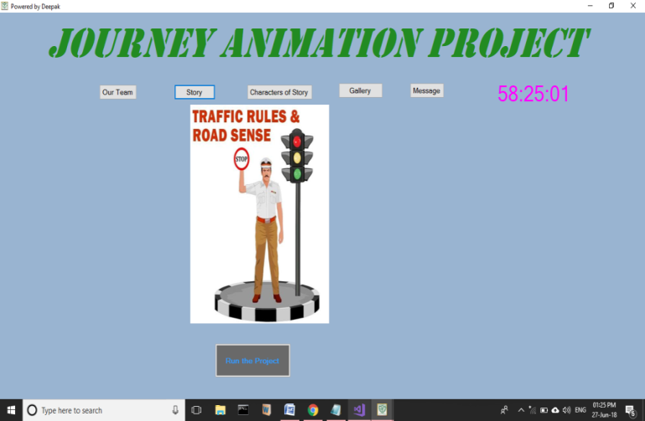

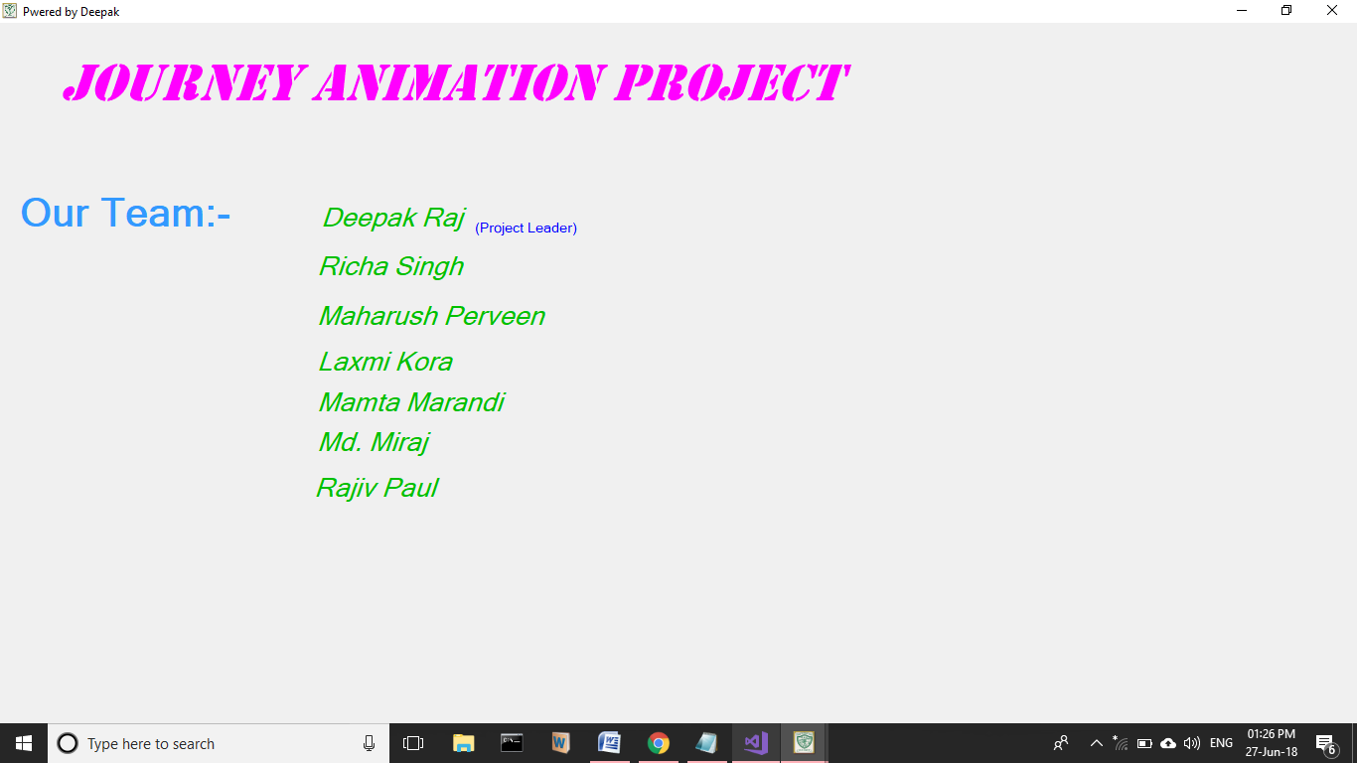

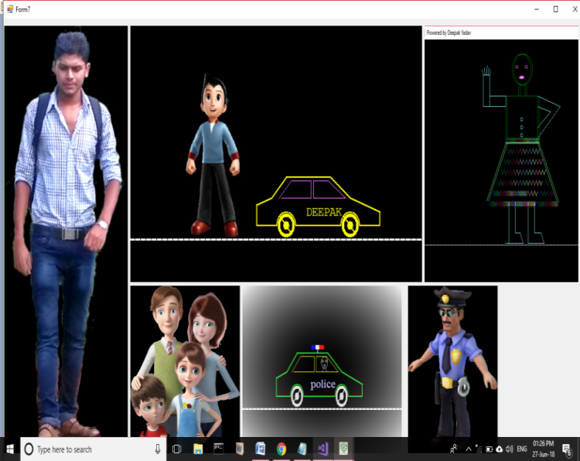 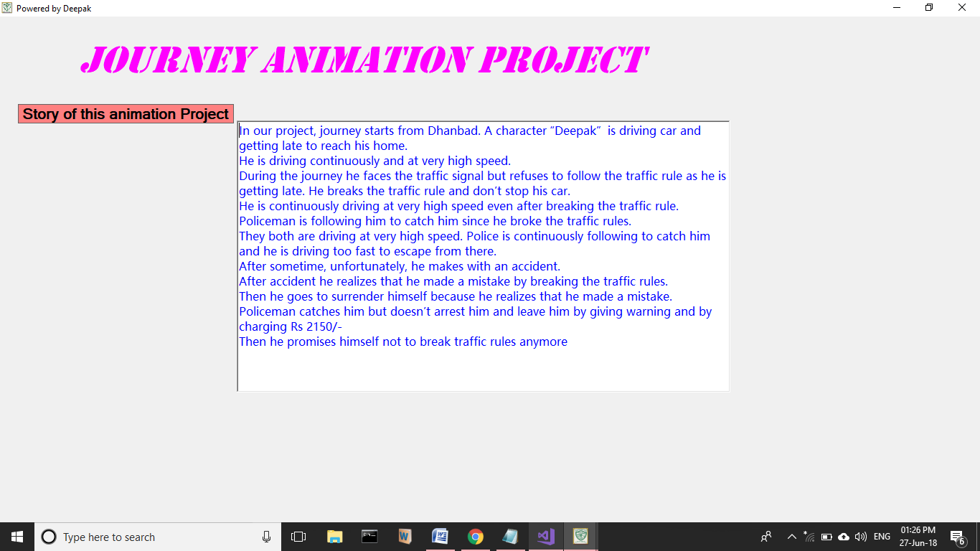

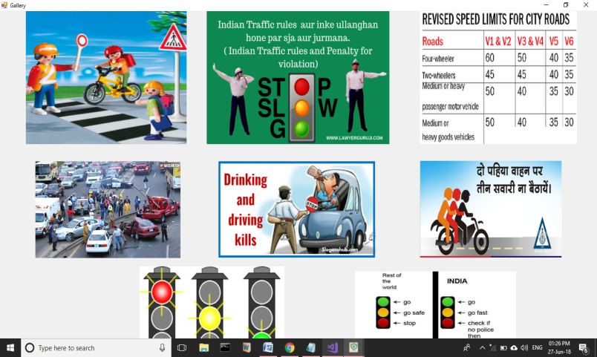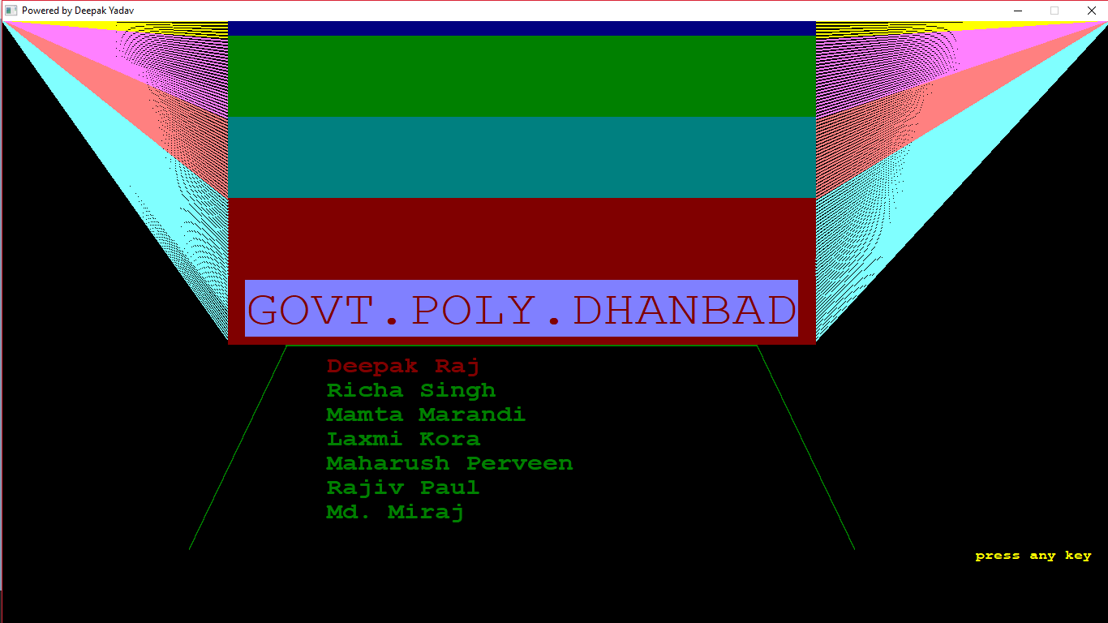 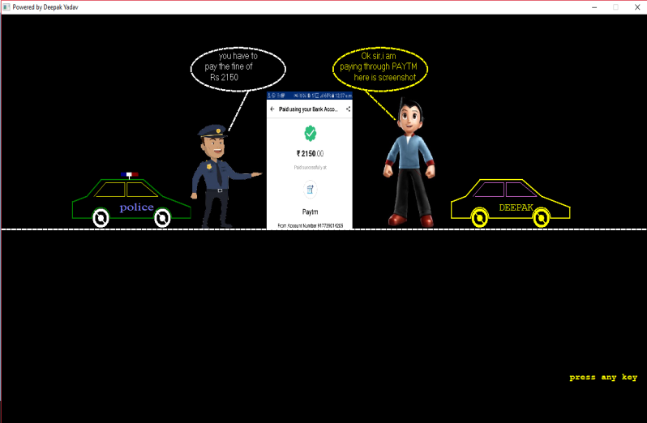

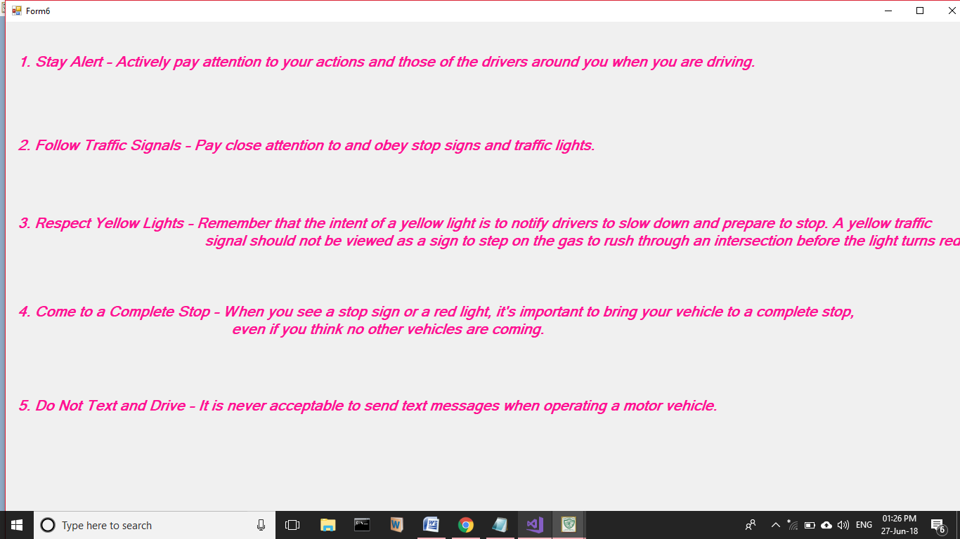

**6. TESTING**

**6.1. SYSTEM TESTING**

The system testing verifies the whole set of program that hang together. Before the system is acceptable by the user testing is very important, it eliminates communication allproblem,programmer negligence or time constraints, which causes error. The strategy of testing include unit testing, integration testing, system testing, implementation testing.

Testing is a series of different test that whose primary purpose is to fully exercise the computer based system. Although each test has a different purpose, all work should verify that all system element have been properly integrated and performed allocated function. Testing is the process checking whether the developed system work. According to the actual requirements and objective of the system.

The philosophy behind testing is to find the errors. A good test is one that undiscovered error. Test cases aredevised with this purpose in mind. Test cases are is a set of data that the system will process as an input. However the data is created with the intent of determining whether the system will process them correctly without any error to produce the required output.

Testing could be viewed as destructive rather than constructive. It is the process of executing the programmed with the intent of finding error. The testing is one that will uncover different classes of errors with the minimum amount of time and effort.

The proposed system testing is done. Testing is performed to ensure that software function appear to be working according to the specifications and that the performance requirement of the system.

**6.2 Testing Methodologies:**

**6.2.1 Black Box Testing**

Black box testing also called behavioral testing focuses on the functional requirements of the software. That is black box testing is enable the software engineered to derive set of input condition that will fully exercise all functional requirements for a program. Black box testing attempts to find errors in the following categories. Incorrect or missing functions. Interface error. Errors in data structures or external in data base access behavior or performance error. Initialization and termination errors. Functional testing and black box testing geared to functional requirements of an application. This type of testing should be done by the testers. Our project done the functional testing of what input given and what output should be obtained. Performance term often used interchangeably with stresses and load testing. Ideally performance testing is defined in requirements documentation or QA or Test Plans.

**6.2.2 White Box Testing**

White box testing sometimes called glass box testing is a test case design method that uses the control structure of the procedural design to derive test case. Using white box testing methods, the software engineer can derive test cases that guarantee that all independent paths within a module have been excercised at least once. Exercise all logical decisions on their true and false sides. Execute all loops at their boundaries and within their operational bounds. Excercise internal data structures to ensure their validity.

**6.2.3 Unit Testing**

The most ‘micro’ scale of testing to test particular functions or code modules. Typically, it is done by programmer and not by tester, as it requires detailed knowledge of internal program design and code. Not always easily done unless the application has a well designed architecture with right code; may require developing test modules or test harnesses.

**Verification and validation**

Verification refers to the set of activity that ensure software correctly implements a specific function. Validation refers to a different set of activity that ensure that the software has been built in traceable to customer requirement.

Verification and validation encompasses a wide array of SQA activity that include formal technical reviews , quality and configuration audits, performance monitoring, simulation, feasibility study, documentation review, database review, algorithm analysis, development testing, qualification testing and installation testing

**Conclusion**

1. **Always follow the traffic rules while driving.**
2. **We should slow down our vehicles and stop at zebra crossing.**
3. **Observe traffic lights and road signs.**
4. **Follow instructions from police officers**
5. **Advance traffic signal controllers and system contribute to the improvement of the traffic problem.**
6. **Senior citizens are involved in a number of traffic accidents every year. Please give extra consideration to elderly people while driving.**